6CS005 Learning Journal - Semester 1 2018/19
Ashish Shrestha, 1828427

Table of Contents

1 POSIX Threads 2

1.1 Password Cracking 2
1.2 Image Processing 2
1.3 Linear Regression 2

2 CUDA 3

2.1 Password Cracking 3
2.2 Image Processing 3
2.3 Linear Regression 3

3 MPI 4

3.1 Password Cracking 4
3.2 Image Processing 4
3.3 Linear Regression 4

4 Verbose Repository Log 5

1 POSIX Threads

1.1 Password Cracking
a. Insert a table of 10 running times and the mean running time.

From above table, we know that the average time taken to crack password is 14.2964 minute.

b. Insert a paragraph that hypothesis's how long it would take to run if the number of initials were to be increased to 3. Include your calculations.

Ans:
From 2 initial number program we know that, it took approximately 14.296 minute time to run program. So, if we increase the number of initials to 3, which means (A-Z) = 26 character then the time should increase by 26 * 14.296 = 371.696 min = 6.1949 hours.

c. Explain your results of running your 3 initial password cracker with relation to your earlier hypothesis.

Ans:
From above (question number b) estimation it was found that it should take 6.1949 hours to run 3 initial password cracking program but actually it took 337.457580566 min = 5.624293009 hours ≈ 6 hours.

e. Write a paragraph that compares the original results with those of your multi-thread password cracker.

From above table, we know that the average time taken to crack password by using multi-threading is 7.2360 minute.

So, we can say that by using multi-threading in password cracking can reduce time by half or more according to the processor of laptop or desktop.

1.2 Image Processing
Insert the image displayed by your program
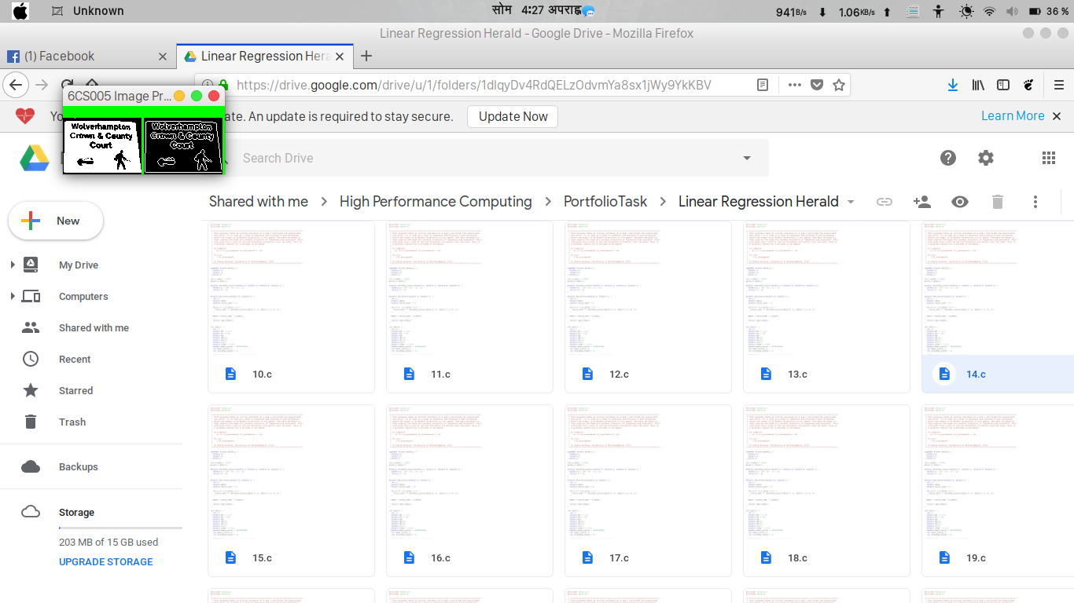

Insert a table that has columns containing running times for the original program and your multithread version. Mean running times should be included at the bottom of the
columns.
Insert an explanation of the results presented in the above table.

Insert the code for your multithreaded edge detector here

1.3 Linear Regression
Insert a scatter plot of your data.
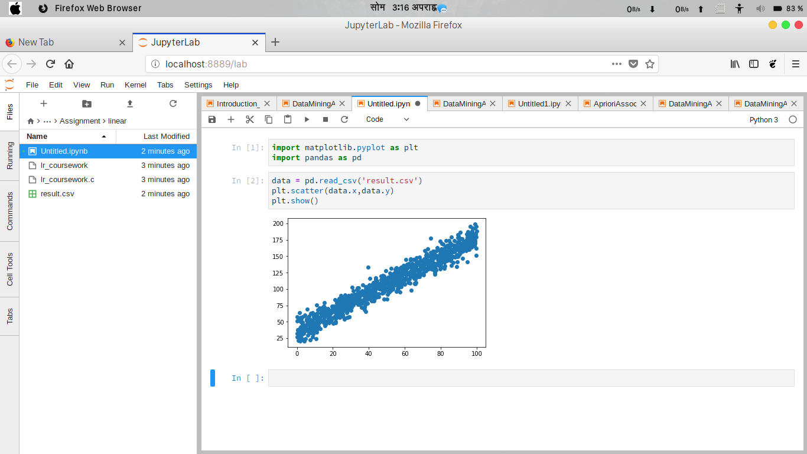

Have 3 guesses at the optimum values for m and c and present them in a graph that overlays your data.
Insert a graph that presents your data with the solution overlaid.
Insert a comment that compares your guesses with the solution found.

Insert a table that shows running times for the original and multithread versions.
Write a short analysis of the results.

2 CUDA
2.1 Password Cracking
Insert a table that shows running times for the original and CUDA versions.

Write a short analysis of the results
Paste your source code for your multithread linear regression program here.

Paste your source code for your CUDA based password cracker here

6CS005 Portfolio, put your name and student number here 4
2.2 Image Processing

Insert a table that shows running times for the original and CUDA versions.
Write a short analysis of the results
2.3 Linear Regression
Insert a table that shows running times for the original and CUDA versions.

Write a short analysis of the results

3 MPI
3.1 Password Cracking
Paste your source code for your CUDA based image processing.

Paste your source code for your CUDA based linear regression

Paste your source code for your MPI based password cracker here

6CS005 Portfolio, put your name and student number here 5
Insert a table that shows running times for the original and MPI versions.
Write a short analysis of the results

3.2 Image Processing

Insert a table that shows running times for the original and MPI versions.
Write a short analysis of the results

3.3 Linear Regression

Insert a table that shows running times for the original and MPI versions.
Paste your source code for your MPI based image processor

Paste your source code for your MPI based linear regression

6CS005 Portfolio, put your name and student number here 6
Write a short analysis of the results

4 Verbose Repository Log

Paste your verbose format repository log here. With subversion this can be achieved by the following:
svn update
svn –v log &gt; log.txt
gedit log.txt
Then select, copy and paste the text here

